Warringah Dressage Association
Proudly Presents
A Clinic with..
Robbie Soster & David McKinnon
22rd & 23rd July 2016
Riders must be WDA, NRC or EA members.

Robbie Soster and David Mckinnon are a young husband and wife dressage combo from the Southern Highlands. Together they own and run Robali Equestrian and Mckinnon Sport Horses where they train horses and riders from YH to Grand Prix.
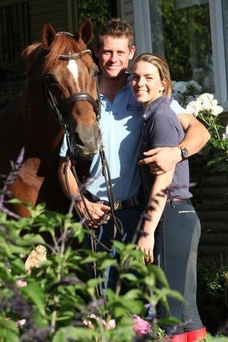
Photo Credit: Roger Fitzhardinge
Robbie is an FEI Grand Prix Dressage Rider, and NCAS Level 1 coach. Robbie has been successful as a young dressage rider and show horse rider. She started professional riding when she came back from a training trip to Germany in 2007. She has since trained and competed a number of horses at all levels of dressage from local competitions to National and international level. She was a member of the youth Olympic dressage team and has been on the state and national dressage squads for almost 10 years. She has also had a lot of success competing in the Arabian ring and the open show ring on a number of different horses, as well as a 2 x EA National and Grand National Champion rider. She has also had much success on a number of different dressage horses at state and national championships.
Dave is also a FEI Grand prix Dressage Rider and NCAS level 1 coach. Dave started his dressage career after leaving school and beginning work at Woodside stables here in Bowral. He then trained with and was the understudy rider for top Dressage rider Brett Parbery for a few years before beginning Mckinnon Sport Horses. He has enjoyed huge success at many different levels, on a number of different horses, at both a State and National level. Dave is currently on both a state and the national dressage squad with two of his horses.
Please note that this clinic is open to riders of all levels and spectators are welcome!
Enquiries: Deb Mills – debrajanemills@gmail.com 0412 666 205

